Safeguarding Information for Parents

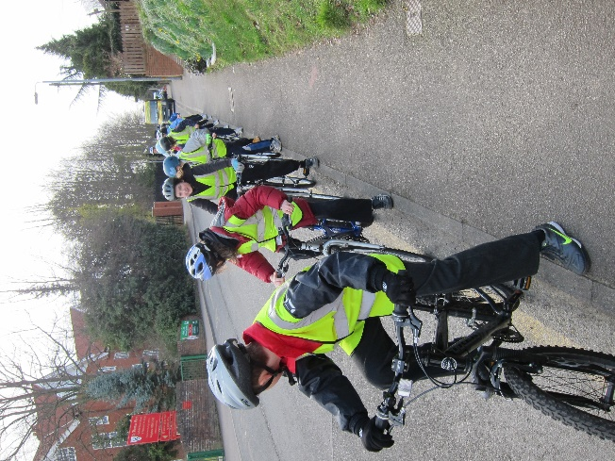
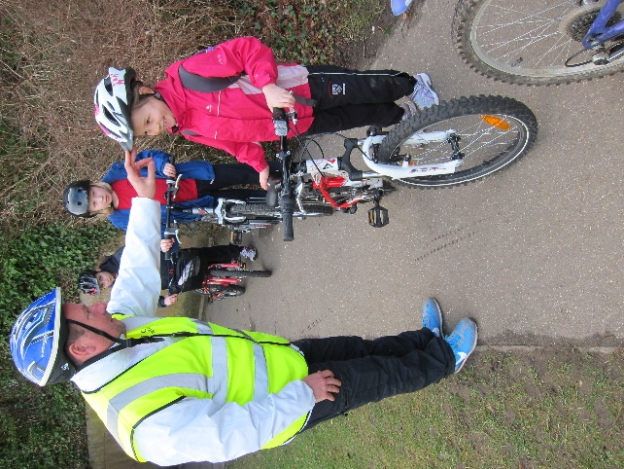

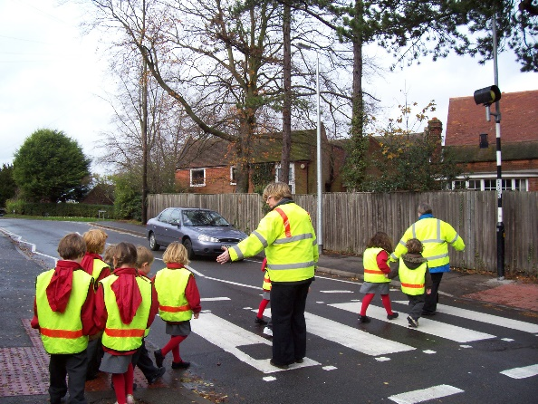

St Thomas More Catholic Primary School
is committed to safeguarding children

May 2020

Policies and Procedures

The Designated Safeguarding and Child Protection Person is Mary Jo Hall, Headteacher. Deputy Designated people are Elaine McNally and Kathie Moy. Designated Governor is Eleanor Bailey.

• All parents are expected to use the front entrance and make themselves known to school staff before entering the school. Parents are discouraged from entering through the pupil doors at the back of school without permission from a member of staff.
• All parents and visitors will be asked to sign in and wear an identity card while on site.
• All parents, staff, governors and people temporarily working on site will have undergone a DBS check and their number recorded and stored in a secure place.
• The school has up-to-date policies on the following safeguarding areas: Safeguarding, Child Protection, Code of Practice, Anti-bullying, Health and Safety, Internet Safety, e-safety, Equality, Race Relations, Food, Educational Visits, PE, PSHE, Sex and Relationships Education.
• There is an E-Safety Booklet for parents available on our website.

Safeguarding within the Curriculum

Through subjects such as RE, PSHE, Geography and Science we teach about the following areas which are related to safeguarding pupils:
• Maintaining a healthy lifestyle—this includes healthy eating and physical exercise
• Health and Safety Rules such as walking inside the building, closing doors, keeping fire exits clear etc.
• About dangers such as fire and water hazards, stranger danger, cycling, crossing the road, drugs etc.
• E-safety is covered both in school and by visiting speakers.
• Safe relationships e.g. those with your family, friends and teachers. How to recognise an unsafe relationship and what to do about it.
• Sex Education including emotional as well as physical development.
• Drug Education—KS1 are taught about medicines while KS2 move onto the issues surrounding illegal substances.
All issues are dealt with throughout the school and revisited many times so that the pupils receive appropriate information for their age.

Safeguarding Events

• Reception have a visit from the Uttlesford Road Safety Officer. They are given practical guidance on crossing a road.
• Year 6 are also visited by the URSO and are taught in a more detailed way about road safety and traffic speed. This is in preparation for going to secondary school.
• In upper Key Stage 2 the children are given Safe Cycling Training.
• Year 6 visit a whole day experience covering many different dangers such as fire safety, safety at stations, electricity pylons, internet chatrooms, drugs, peer pressure.
• Year 3 are visited by a Fire Safety Officer who teaches the children about fire both inside and outside the home.
• Year 3 are visited by a Dental Nurse and learn how to look after their teeth.
• Years R and 6 are checked (heights, weight, sight) by the School Nurse.
• The School Nurse is a frequent visitor and will follow up any concerns made by staff about pupils.

Parent Partnership

All parents and carers of children at St Thomas More School are asked to support the school policies at school and at home so that a clear, safe message is received by our pupils.

Should any parent have a concern about their own or another child in the school or the safety policies and procedures around the school, that parent should speak in confidence to Mrs Hall or in her absence Mrs McNally (Deputy Headteacher).

